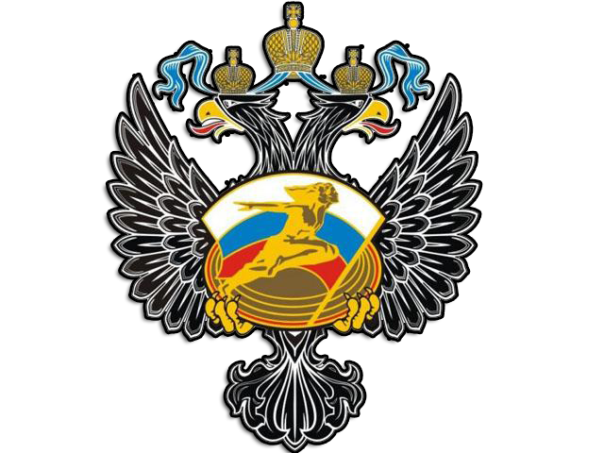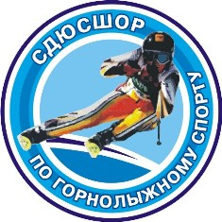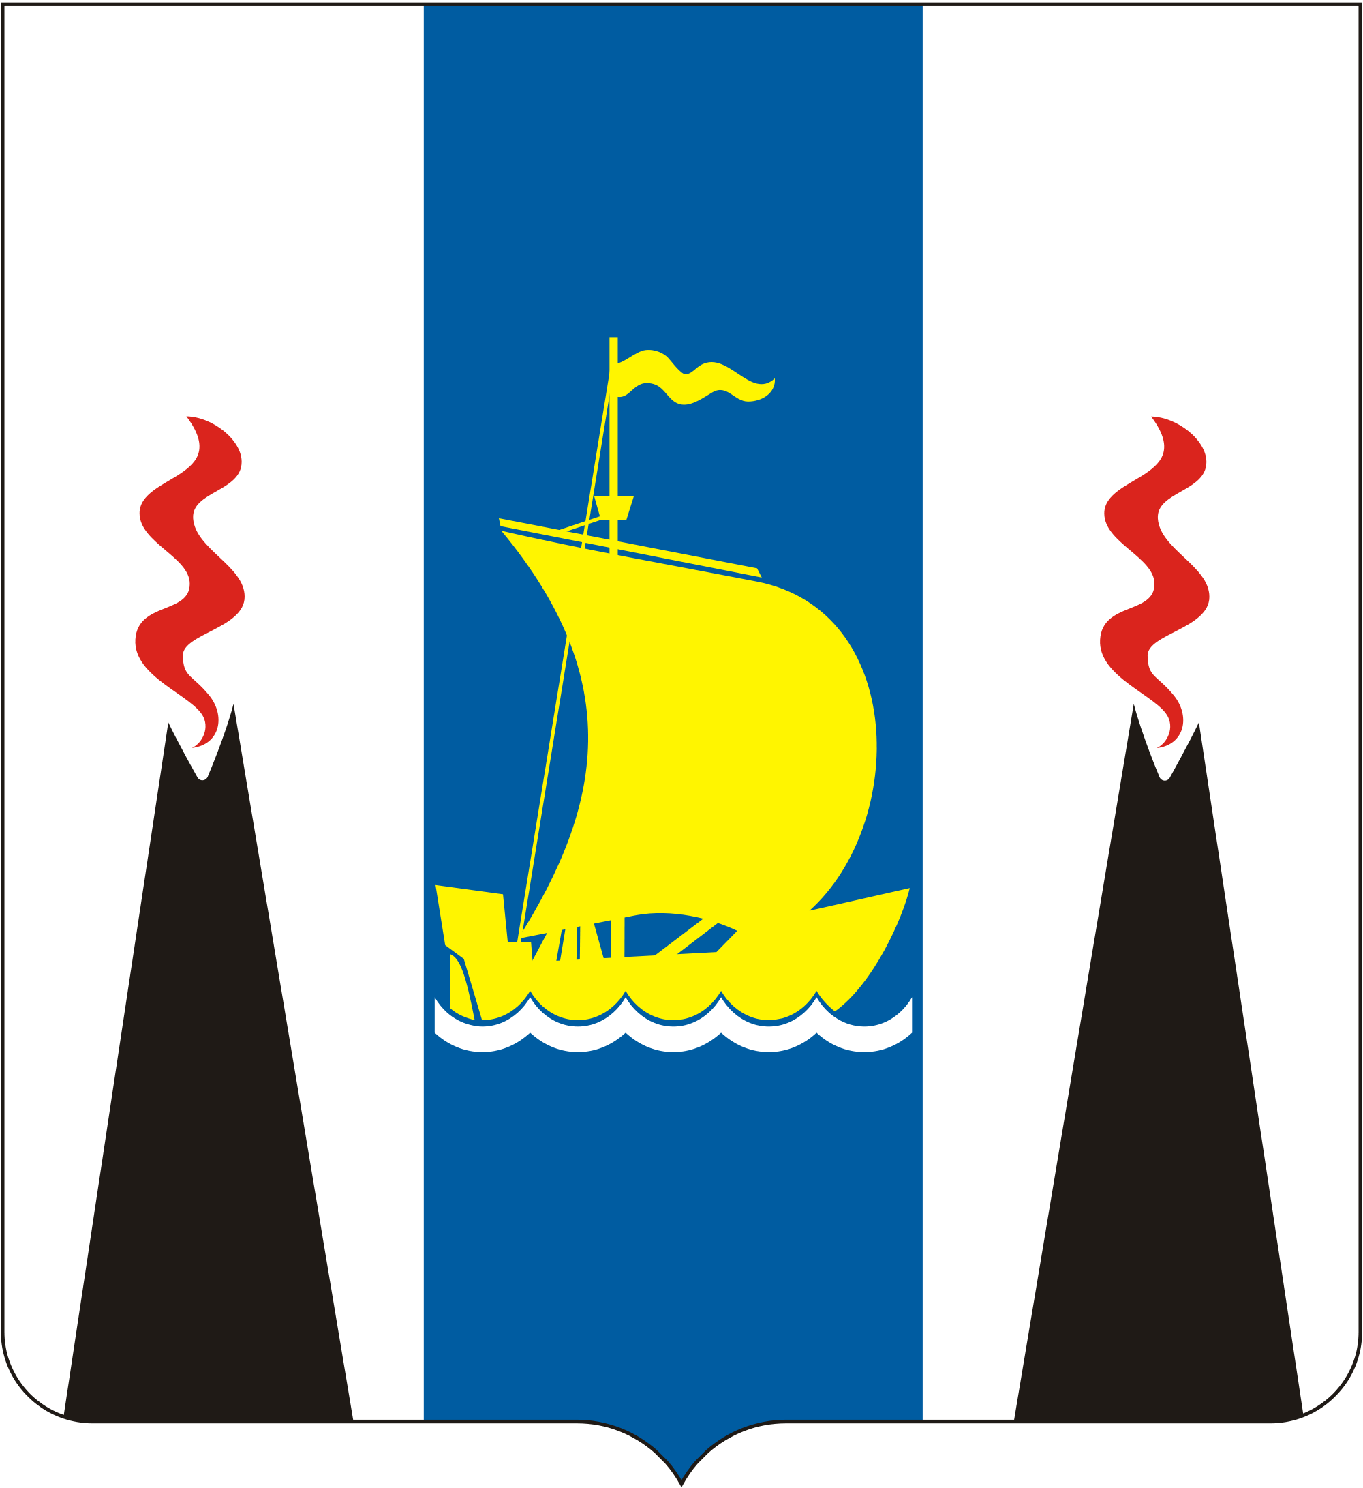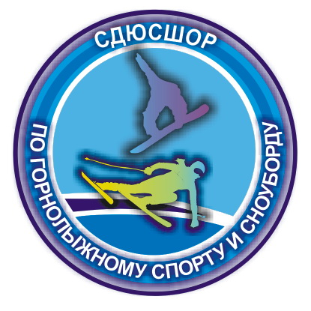

Team Invitation
FIS Race 2018
Yuzhno-Sakhalinsk, Big Air, Slopestyle, two-days stage, February 14-18
Welcome to the FIS Race Snowboard Sport Centre “Mountain Park”, which will be held 14-18 February (Big air and Slopestyle) Park Ski Center, Yuzhno-Sakhalinsk, Russia
Russian Snowboard Federation will host the event in accordance with the FIS International Competition Rules. All athletes who qualify in accordance with the FIS Rules UPS is invited to take part in competition

Last season video from Sport Centre “Mountain Park” is available here: https://www.youtube.com/watch?v=j6ETvUzP0mY&feature=youtu.be
https://www.youtube.com/watch?v=CbJYIx8IZak

1. PASSPORT and VISA

A foreign visitor traveling to Russia must have a passport valid for at least next 6 months after the date of departure from Russia.
You will need a visa to enter Russia, procedures and all needed documents will be supported by OC.
Organising Committee FIS Race Snowboard, Sport Centre “Mountain Park”
c/o Vlasenko Pavel
Sakhalin Snowboard Region Federation, Yuzhno-Sakhalinsk
St. Gorkogo, 7 building 4 Yuzhno-Sakhalinsk
693010,
St. Gorkogo, 7 building 4 Yuzhno-Sakhalinsk
693010,
Russia
Tel./fax: +7 (4242) 76-05-57

E-mail: sakh-alpineski@mail.ru
Mob.tel: +7(962)1189797

2. Entries

Entries will be accepted from National Ski Associations in accordance with the FIS quotas and rules. Please, complete the Team Entry and forward it to the Organizing Committee by e-mail or fax:

OC Organising Committee FIS Race Snowboard, Sport Centre “Mountain Park”
c/o Vlasenko Pavel
Sakhalin Snowboard Region Federation, Yuzhno-Sakhalinsk
St. Gorkogo, 7 building 4 Yuzhno-Sakhalinsk
693010,
Russia
Tel./fax: +7 (4242) 76-05-57

E-mail: sakh-alpineski@mail.ru
Mob.tel: +7(962)1189797

Official entries must be received by the Organizing Committee (OC) not later than
February 5, 2017 (announcement of team size)

3. Registration

Team registration will take place on Wednesday, February 14, 2018 at the race office. The race office is located at the Ski school, Yuzhno-Sakhalinsk St. Gorkogo, 7 building 4 Yuzhno-Sakhalinsk 2th floor.

4. Accommodation

Each participant will pay CHF 60 (in accordance with the FIS set exchange rate) paid per day/person directly to the Organizing Committee FIS Race Snowboard, Sport Centre “Mountain Park”. The accommodation is provided at a half board bases and in accordance with the FIS rules.
PLEASE NOTE: The Organizing Committee can only accept payment in local currency cash.
Please forward the applications for accommodation to (sakh-alpineski@mail.ru).
Accommodation will be provided from the February 14, 2018, until departure on February 18, 2018.
Each team will be held responsible for any damage incurred during the stay.
The official hotel of the event is Santa Resort Hotel, located at the Sport Centre “Mountain Park”
Theaddressofthehotelis: Santa Resort Hotel 3, Venskaya street, Yuzhno-Sakhalinsk, 693010, Russiahttp://www.santahotel.ru E-mail: reservation@santahotel.ru, front-office@santahotel.ru
* The OC will provide accommodation guidance for those who arrive before February 12, 2018.

5. Bibs

All competitors must wear bibs during all official trainings, competitions and award ceremonies.

6. Accident Insurance

Each competitor must have his/her own medical insurance. The Organizing Committee, Russian Snowboard Federation, sponsors, suppliers, their agents and the FIS decline any responsibility for accidents, damaged or lost equipment and second and third party claims during the event.

7. Liability

All athletes, officials and members of the National Association who attend and participate in the event shall do so at their own risk. The Organising Committee, Sport Centre “Mountain Park”, Russian Snowboard Federation, sponsors, suppliers, their agents, employees and volunteers shall not be responsible for any losses or injuries incurred or suffered by any athletes, officials or other person in conjunction with the organizing or staging of the event.
8. Official Notice Board

The official Notice Board will be located at the welcome desk at the hotel.
9. Training

Trainings are to take place according to the schedule of the event.
10. Event Fee

There is an event fee Euro 20.-for training and event-days – this includes entry fee, lift passes for all event days including training (15, 16, 17 February). It must be paid by cash directly to the Organizing Committee upon registration at the race office.
13. Announcements

An English-speaking announcer will be provided by the OC for the event.

Preliminary program (subject to changes), as of 14th February 2018
 | Arrival Day | Training BA,SS | Competition BA  Qualification/Finals | Competition SBS  Qualification/Finals
 | Thursday, 14.02.2018 | Friday,  15.02.2018 | Saturday,  16.02.2018 | Sunday,  17.02.2016
Race Office Opening Hours: | 16.00-18.00 Ski school Yuzhno-Sakhalinsk | 9.00-18.00 Sport Centre “Mountain Park” | 9.00-18.00 TCM Sport Centre “Mountain Park” | 9.00-17.00 TCM Sport Centre “Mountain Park”
Lift open: |  | 9.30 | 9.30 | 9.30
Inspection/ Training: |  | 10.00 | H1 10.00-10.30  H2 11.30-12.00  W 13.00  W  W 13.00-13.30 | H1 10.00-10.30  H2 11.30-12.00  W 13.00-13.30
Entry for all closed: |  | 13.00
Forerunners (4):
Start time Qualification: |  |  | H1 10.30, H2 12.00, W 13.00 | H1 10.30, H2 11.30, W 13.00
Start Intervalls: |  |  | Heat 1 Men 1 - 1,15 min 2 runs approx.40 min  Heat 2 Men 25-50 - 1,30 min 2 runs approx. 60 min  Women 1 25 2 runs – 1,30 min approx. 60 min | Heat 1 Men 1-15 - 1,30 min 2 runs approx.60 min  Heat 2 Men 25-50 - 1,30 min 2 runs approx. 60 min  Women 1-25 2 runs – 1,30 min approx. 60 min
Timed run around: |  |  | Approx. 90sec. | Approx. 90sec.
Course Setter:
Connection Coach: |  |  | TBD | TBD
Inspection/Training Finals: |  |  | 14.00-14.40 (tbd) | 14.00-14.40 (tbd)
Entry for all closed: |  |  | 14.50 at the start | 14.50 at the start
Forerunners (4): |  |  | 14.55 | 14.55
Start Time Final: |  |  | 15.00-16.00 | 15.00-16.00
Start interval: |  |  | 60 min  Heat Men 1-12 - 1,30 min = 40 min  Heat Women 1-6 – 1,30 min = 20 min | 60 min  Heat Men 1-12 - 1,30 min = 40 min  Heat Women 1-6 – 1,30 min = 20 min
Flower ceremony: |  |  |  | Immediately after race finish area
Prizegiving ceremony: |  |  |  | Immediately after race finish area
Public bibdraw: |  | ----
Team Captains Meeting: | 18.00 TCM | 14.00 TCM Sport Centre “Mountain Park” | 17.00 TCM Sport Centre “Mountain Park”
TD:

